OBJECTIVE QUESTIONS

(Q1) What is the total no. of attributes present in the data?
Approach- With the help of COUNTA function, we can count total no. of columns/attributes present in the Tickets sheet & IT Agents sheet.
Observation- Total 16 Attributes are present in the data & Agent ID attribute is common in Both sheets.
Refers To: Obj. Q1 Sheet.
FORMULA=COUNTA (Tickets! A1:J1, IT_Agents! A1: F1)
Attributes- (A) TICKETS Sheet.
- ID Ticket
- Fecha
- Employee ID
- Agent ID
- Request Category
- Issue Type
- Severity
- Priority
- Resolution Time (Days)
- Satisfaction Rate

(B) IT Agents Sheet
- Agent ID
- Full Name
- Email
- Year of Birth
- Month of Birth
- Day of Birth
(Q2) Which columns have inconsistent or missing values, and what is the count of such values?
Approach- After filtering the data, found there is no missing or inconsistent values present in the data.
But, in severity & priority columns (TICKETS sheet), some values have spelling errors which are corrected by Find & Replace Method.
Observation- Data has no duplicate values & all the ID Tickets are unique.
- Severity- Replaced 4,836 instances of “Mayor” with “Major” & Replaced 356 instances of “Unclasified” with “Unclassified” in Tickets sheet.
- Priority- Replaced 29,410 instances of “Unassiged” with “Unassigned” in Tickets sheet.

(Q3) What is the average daily ticket volume over time?
Approach-This can be achieved by dividing the total no. of ID Tickets by the total no. of days.
Refers To: Obj.Q3 Sheet.
AVERAGE= Total ID Ticket/Count of unique days
Observation- The average daily ticket volume is 53.36.

(Q4) What is the distribution of ticket categories (e.g., Login Access, System, Software)?
Approach- Distribution of ticket categories can be analysed by using pivot table.
Refers To: Obj.Q4 Sheet.

- The pivot table is created by organizing Request Category in rows, Year in columns and count of tickets in values.
- Slicer is added to filter the data by year.
Request Category | Count of ID Ticket
Hardware | 9733
Login Access | 29193
Software | 19570
System | 39002
Grand Total | 97498

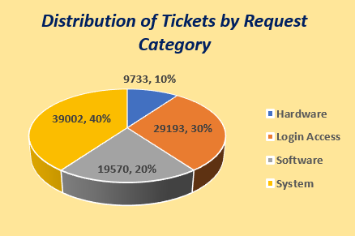
Observation-
- System and Login Access requests together account for nearly 75% of total ticket volume, indicating that most support demand is concentrated around system operations and access management.
- In each request category, no. of tickets is increased over the years.
- System-related tickets represent the largest share (40%), followed by Login access (30%), Software (20%) and Hardware (10%).

(Q5) How many tickets has each agent handled?
Approach-With the help of pivot table, we can find the no. of tickets handled by each Agent by putting Agent ID in Rows & Ticket ID in Values.
Refers To: Obj.Q5 Sheet.
Agent ID | Count of ID Ticket
1 | 1969
2 | 1968
3 | 2021
4 | 1988
5 | 2000
6 | 1949
7 | 1935
8 | 1960
9 | 1949
10 | 1974
11 | 1956
12 | 1897
13 | 1856
14 | 1942
15 | 1991
16 | 1926
17 | 1961
18 | 1892
19 | 1984
20 | 1920
21 | 1889
22 | 1966
23 | 1915
24 | 2003
25 | 1906
26 | 1963
27 | 1968
28 | 1946
29 | 1931
30 | 1963
31 | 1987
32 | 1974
33 | 1958
34 | 1927
35 | 2007
36 | 1913
37 | 1931
38 | 1938
39 | 2026
40 | 1920
41 | 1966
42 | 1945
43 | 1897
44 | 1943
45 | 1929
46 | 1950
47 | 1933
48 | 2027
49 | 1890
50 | 1949
Grand Total | 97498

Observation-
- Each agent handles the specific no. of Tickets (eg~Agent-2 handles 1968 tickets).
- Few Agents handles more than 2,000 Tickets as compared to others (See highlighted cells).

(Q6) How can you extract the domain from the email addresses in the IT Agents sheet?
Approach-BY using LEFT, RIGHT, LEN & FIND functions, we can extract the domain from the email
Refers To: IT Agents Sheet.
FORMULA=LEFT (RIGHT (C2, LEN(C2)-FIND ("@", C2)),13)

(Q7) How can you find the full name of an agent given their Agent ID?
Approach- BY using VLOOKUP OR XLOOKUP, we find the full name by taking Agent ID as lookup value.
Refers To: Tickets Sheet.
FORMULA= VLOOKUP ($D2,'IT Agents'! $A$1: $B$51,2,0)

(Q8) What is the count of each issue type (e.g., IT Error, IT Request)?
Approach- The count of tickets in each issue type can be analysed using pivot table by organizing issue type in rows, Year in columns and count of tickets in values.
Refers To: Obj.Q8 Sheet.
Count of ID Ticket | Year
Issue Type | 2016 | 2017 | 2018 | 2019 | 2020 | Grand Total
IT Error | 3294 | 3680 | 4653 | 5344 | 7307 | 24278
IT Request | 9757 | 11235 | 14301 | 16146 | 21781 | 73220
Grand Total | 13051 | 14915 | 18954 | 21490 | 29088 | 97498

Observation-
- It clearly indicates that each year, the number of tickets related to IT Errors increases nearly 3 times compared to IT Requests.

(Q9) What is the daily average resolution time for tickets?
Approach- To get daily average resolution time for tickets, we can use either AVERAGE function or PIVOT table by putting Resolution Time (Days) in Values.
Refers To: Obj.Q9 Sheet.
FORMULA= AVERAGE (Tickets! I2: I97499)
PIVOT TABLE-
Average of Resolution Time (Days)
4.553149808

Observation-
- Daily AVG. Resolution time is 4.553149808.

(Q10) How has the volume of tickets changed over time?
Approach- Volume of Tickets changed over time(year), can be understood easily with the help of pivot table, by organizing Year in Rows and ID Tickets in Values.

Refers To: Obj.Q10 Sheet
Year | Count of ID Ticket
2016 | 13051
2017 | 14915
2018 | 18954
2019 | 21490
2020 | 29088
Grand Total | 97498

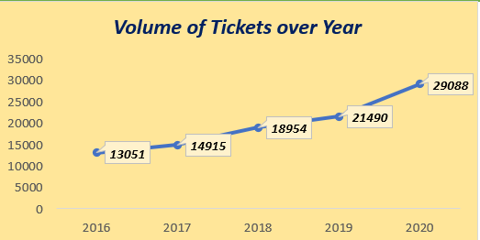

Observation-
- Tickets volume has steadily increased over the years.
- Spikes were noticed in 2018 and 2019, with the highest spike in 2020.

(Q11) What is the average age of the IT agents?
Approach-To calculate Avg. age of IT Agents, we have to do 2 steps-
(A)Firstly, we have to the find age of each Agent, by DATEDIF function.
Refers To: IT Agents Sheet.
FORMULA= DATEDIF (DATE (D2, E2, F2), TODAY(),"y")

(B)Then, we calculate the AVG. age of IT Agents, AVERAGE function.
Refers To: Obj.Q11 Sheet.
FORMULA= AVERAGE ('IT Agents'! H2: H51)

(Q12) Is there a correlation between the severity of issues and the resolution time?
Approach-A pivot table is created with Severity in rows and Average of resolution time in value and create Line chart to visualized the data to understand the co-relation between severity and resolution time.
Refers To: Obj.Q12 Sheet.
Severity | Average of Resolution Time (Days)
Major | 3.907981803
Minor | 3.43534101
Normal | 4.663609908
Unclassified | 2.876404494
Urgent | 2.001436782
Grand Total | 4.553149808

Observation-
- The data shows that Urgent severity tickets are resolved the fastest, within 2 days.
- Major severity tickets are resolved in approximately 4 days.
- Normal severity tickets take around 4.5 days to resolve.
- Minor severity tickets are resolved in about 3 days.

(Q13) How many categorical columns are there in the data? [Search about categorical and continuous data, and try to answer this question].
Approach- Categorical data refers to data that represents labels, groups, or categories rather than numerical measurements.
Types of Categorical Data:
(1) Nominal data consists of categories that have no natural order or ranking.
(2) Ordinal data consists of categories that have a meaningful order or ranking.
- Continuous data refers to numerical data that represents measurable quantities.

Observation- There are 11 categorical columns present in the data.
- Nominal- ID Ticket, Fecha, Employee ID, Agent ID (Ticket), Issue Type, Request Category, Email, Full Name.
- Ordinal- Severity, Priority, Agent ID (IT Agent).
----------------------------------------------------------------------------------------------

SUBJECTIVE QUESTIONS

(Q1) If there is an investment, should it be used to hire more IT agents, improve training programs, or upgrade ticket management software? Analysis- Perform a cost-benefit analysis using ticket resolution and satisfaction metrics.

Approach- To hire more IT agents & improved training programs or upgrade ticket management software through investments, firstly we have to take different parameters through multiple pivot tables.
Refers To: SUBJECTIVE Q1 Sheet.
(A)TABLE-1: Create Pivot table by organizing Agent ID in Rows & Count of ID Ticket, AVG. Satisfaction Rate and AVG. Resolution Time in Values.

Agent ID | Count of ID Ticket | Average of Satisfaction Rate | Average of Resolution Time (Days)
1 | 1969 | 4.340274251 | 5.44591163
2 | 1968 | 4.473577236 | 3.596544715
3 | 2021 | 3.615042058 | 5.381989114
4 | 1988 | 4.187625755 | 5.243963783
5 | 2000 | 4.376 | 4.259
6 | 1949 | 3.592611596 | 5.32067727
7 | 1935 | 3.97622739 | 5.524031008
8 | 1960 | 4.436734694 | 3.834183673
9 | 1949 | 3.690097486 | 4.523345305
10 | 1974 | 4.415906788 | 4.298378926
11 | 1956 | 3.63803681 | 4.778118609
12 | 1897 | 4.489720611 | 4.05640485
13 | 1856 | 4.282327586 | 5.322198276
14 | 1942 | 4.085478888 | 4.901132853
15 | 1991 | 4.4716223 | 3.655951783
16 | 1926 | 3.665109034 | 4.317757009
17 | 1961 | 4.341662417 | 3.705252422
18 | 1892 | 3.991014799 | 4.731501057
19 | 1984 | 3.04233871 | 4.999495968
20 | 1920 | 4.147916667 | 4.4078125
21 | 1889 | 4.401270513 | 3.705664373
22 | 1966 | 3.628179044 | 5.511190234
23 | 1915 | 4.377545692 | 4.55770235
24 | 2003 | 4.441337993 | 4.227159261
25 | 1906 | 3.601259182 | 5.204616999
26 | 1963 | 3.990830362 | 4.754457463
27 | 1968 | 4.222052846 | 3.651422764
28 | 1946 | 3.612024666 | 5.409558068
29 | 1931 | 4.461418954 | 3.716727084
30 | 1963 | 3.847682119 | 4.867040245
31 | 1987 | 4.364368395 | 3.66935078
32 | 1974 | 4.123100304 | 4.886524823
33 | 1958 | 3.631256384 | 4.804392237
34 | 1927 | 4.596782564 | 3.636222107
35 | 2007 | 4.399103139 | 4.369207773
36 | 1913 | 4.198118139 | 3.918452692
37 | 1931 | 3.660797514 | 4.595028483
38 | 1938 | 4.444272446 | 4.643446852
39 | 2026 | 4.344521224 | 5.554787759
40 | 1920 | 3.667708333 | 4.286979167
41 | 1966 | 3.783316378 | 4.554933876
42 | 1945 | 4.361953728 | 4.058097686
43 | 1897 | 3.913020559 | 3.846072746
44 | 1943 | 4.411219763 | 4.720020587
45 | 1929 | 3.821150855 | 3.700362882
46 | 1950 | 4.320512821 | 5.319487179
47 | 1933 | 4.170201759 | 3.824624935
48 | 2027 | 4.407992107 | 4.514553527
49 | 1890 | 4.355026455 | 5.343915344
50 | 1949 | 4.204720369 | 5.451513597
Grand Total | 97498 | 4.100648218 | 4.553149808

(B)TABLE-2: Create Pivot table by organizing the Year in Rows and & Count of ID Ticket, AVG. Satisfaction Rate and AVG. Resolution Time in Values.
Also, Line chart is made to visualize the data.
Year | Count of ID Ticket | Average of Satisfaction Rate | Average of Resolution Time (Days)
2016 | 13051 | 3.979695043 | 4.551758486
2017 | 14915 | 4.068119343 | 4.530070399
2018 | 18954 | 4.091853962 | 4.558668355
2019 | 21490 | 4.122382503 | 4.520800372
2020 | 29088 | 4.161269252 | 4.585911716
Grand Total | 97498 | 4.100648218 | 4.553149808
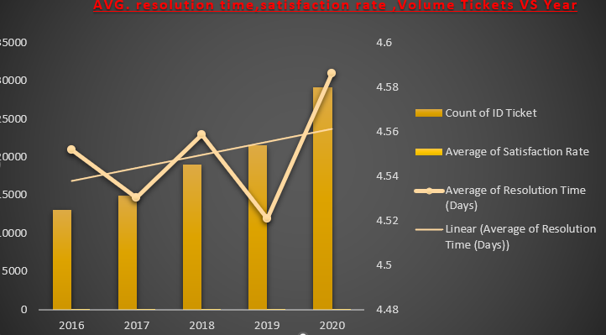

(C)TABLE-3: Create Pivot table by organizing the Severity in Rows, Count of ID Tickets in Values & Priority in Columns.

Count of ID Ticket | Priority
Severity | Unassigned | Low | Mid | High | Grand Total
Unclassified | 115 | 80 | 55 | 106 | 356
Minor | 626 | 549 | 407 | 676 | 2258
Normal | 26826 | 15282 | 14468 | 32080 | 88656
Major | 1434 | 614 | 713 | 2075 | 4836
Urgent | 409 | 169 | 202 | 612 | 1392
Grand Total | 29410 | 16694 | 15845 | 35549 | 97498

Insights- # From Table 1, only a few agents (ID 3, 24, 35, 39 & 48) handle more than 2,000 tickets, compared to other agents.
- Average satisfaction ratings vary slightly among agents as some have above 4+ ratings, others have around 3+ ratings.
- But, most of the IT Agents takes time 4 to 6 days to resolved the tickets.
# From Table 2, the data shows a healthy trend as no. of tickets increase yearly, average satisfaction remains consistent, and average resolution time is around 4.5 days.
#From Table-3, there is inconsistency between severity & priority, as Normal severity tickets are large in no, followed by Major, Minor, Urgent & Unclassified.

Recommendations-
- A comprehensive training program must be given to all agents to improves the skills where they lacking, so that they able to handle large no. of tickets and maintains the avg. satisfaction rate and reduce the resolution time.

- Distribute the no. of tickets in equal proportion to each agent, so that it reduced the workload for few agents.

- Investment on upgrade ticket software must be considered, as there is mismatch between severity & priority, as large no. of normal severity tickets are unassigned, which must be tackle by update software and assigned to correct priority levels.

(Q2) Which agents need additional training based on their performance metrics? Analysis: Identify agents with the lowest satisfaction ratings and longest resolution times.
Approach- A pivot table is created by organizing the Agent ID in rows, Average satisfaction rate and average resolution time in values.
Refers To: SUBJECTIVE Q2 Sheet.
Agent ID | Average of Satisfaction Rate | Average of Resolution Time (Days)
1 | 4.340274251 | 5.44591163
2 | 4.473577236 | 3.596544715
3 | 3.615042058 | 5.381989114
4 | 4.187625755 | 5.243963783
5 | 4.376 | 4.259
6 | 3.592611596 | 5.32067727
7 | 3.97622739 | 5.524031008
8 | 4.436734694 | 3.834183673
9 | 3.690097486 | 4.523345305
10 | 4.415906788 | 4.298378926
11 | 3.63803681 | 4.778118609
12 | 4.489720611 | 4.05640485
13 | 4.282327586 | 5.322198276
14 | 4.085478888 | 4.901132853
15 | 4.4716223 | 3.655951783
16 | 3.665109034 | 4.317757009
17 | 4.341662417 | 3.705252422
18 | 3.991014799 | 4.731501057
19 | 3.04233871 | 4.999495968
20 | 4.147916667 | 4.4078125
21 | 4.401270513 | 3.705664373
22 | 3.628179044 | 5.511190234
23 | 4.377545692 | 4.55770235
24 | 4.441337993 | 4.227159261
25 | 3.601259182 | 5.204616999
26 | 3.990830362 | 4.754457463
27 | 4.222052846 | 3.651422764
28 | 3.612024666 | 5.409558068
29 | 4.461418954 | 3.716727084
30 | 3.847682119 | 4.867040245
31 | 4.364368395 | 3.66935078
32 | 4.123100304 | 4.886524823
33 | 3.631256384 | 4.804392237
34 | 4.596782564 | 3.636222107
35 | 4.399103139 | 4.369207773
36 | 4.198118139 | 3.918452692
37 | 3.660797514 | 4.595028483
38 | 4.444272446 | 4.643446852
39 | 4.344521224 | 5.554787759
40 | 3.667708333 | 4.286979167
41 | 3.783316378 | 4.554933876
42 | 4.361953728 | 4.058097686
43 | 3.913020559 | 3.846072746
44 | 4.411219763 | 4.720020587
45 | 3.821150855 | 3.700362882
46 | 4.320512821 | 5.319487179
47 | 4.170201759 | 3.824624935
48 | 4.407992107 | 4.514553527
49 | 4.355026455 | 5.343915344
50 | 4.204720369 | 5.451513597
Grand Total | 4.100648218 | 4.553149808

Insights- After applying Conditional Formatting on Pivot table- Average satisfaction Rate (below/< 4) and Average Resolution time (greater/> 5), it clearly indicates that the agents which have exact match highlighted cells in both avg. satisfaction rate (GREEN) and avg. resolution time (RED), needs additional training.

Recommendations-
- 6 Agents are identified, which need additional training to improve their skills & performance.

Agent ID | AVG. Satisfaction Rate | AVG. Resolution Time
3 | 3.615042058 | 5.381989114
6 | 3.592611596 | 5.32067727
7 | 3.97622739 | 5.524031008
22 | 3.628179044 | 5.511190234
25 | 3.601259182 | 5.204616999
28 | 3.612024666 | 5.409558068

(Q3) Do certain categories of requests have longer resolution times? Analysis: Analyse the resolution times by request category.
Approach- A pivot table is created by organizing Request Category in Rows & Average of Resolution Time (Days) in Values. A slicer is also added to filter the data by request category.
Refers To: SUBJECTIVE Q3 Sheet.
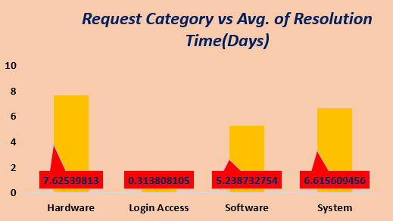

Insights & Recommendation-
- From the data, Hardware and System tickets have the longest average resolution times, 7.6 days and 6.6 days respectively, indicating higher technical complexity.
- Login Access tickets are resolved the fastest, taking only about 1/2 day (0.3 day), while Software tickets take a moderate 5.2 days on average.
- For Normal (7.8 days), Minor (6.7 days), and Unclassified (6.4 days) severities, Hardware tickets consistently take longer time to resolve than other categories—except for Urgent tickets, where Hardware issues are resolved fastest (2.7 days).
- Across all severity level, Login Access related tickets take least time (1/2 day) as compared to other request categories.

- The ticketing system should be upgraded, to automatically match ticket severity with the correct priority level, ensuring faster assignment and better handling of critical issues. This will reduce delays, improve response time, and increase overall support efficiency.
- Focused on improving system performance and automating login access, since these two areas generate most of the support tickets.

(Q4) How effective are the current software tools in managing IT tickets? Analysis: Evaluate performance metrics before and after the implementation of new tools.
Approach- A pivot table is created by organizing the severity in Rows, Priority in columns & count of ID Tickets in Values. Additional, slicer is added to filter the data by priority, to check whether the current software tools are effective in managing tickets.
Refers To: SUBJECTIVE Q4 Sheet.

Severity | Count of ID Ticket
Major | 4836
Minor | 2258
Normal | 88656
Unclassified | 356
Urgent | 1392
Grand Total | 97498

Insights & Recommendation-
- From data, it clearly shows that the large no. of severity tickets unassigned, especially in Normal severity tickets (26,826).
- Major, Minor, Urgent, and Unclassified tickets have the least unassigned volume.
- Current ticketing software tools didn’t apply properly to tackle unassigned severity tickets, which create inconsistencies between severity & priority.

- The ticketing system should be upgraded, to automatically match ticket severity with the correct priority level, ensuring faster assignment and better handling of critical issues.
This will reduce delays, improve response time, and increase overall support efficiency.

(Q5) How has the performance of the IT support team changed over time (e.g., monthly or quarterly)? Analysis: Trend analysis using time series charts.

Approach- By creating multiple pivot tables and charts to understand and visualize the data.
Refers To: SUBJECTIVE Q5 Sheet.
- In Table-1, organizing Year in Rows & Count of ID Tickets in Values.
- In Table-2, organizing Months in Rows, Avg. Satisfaction Rate & Avg. Resolution days in Values. Slicer is also added to filter the data by year.
- In Table-3, organizing Request Category in Rows, Avg. Satisfaction Rate & Avg. Resolution days in Values.
Year and Quarter is added as slicer to filter the data.

TABLE-1
Year | Count of ID Ticket
2016 | 13051
2017 | 14915
2018 | 18954
2019 | 21490
2020 | 29088
Grand Total | 97498

TABLE-2
Month | Average of Satisfaction Rate | Average of Resolution Time (Days)
Jan | 4.151615576 | 4.575807788
Feb | 4.071763068 | 4.586254904
Mar | 4.073650948 | 4.557243559
Apr | 4.113770946 | 4.562429129
May | 4.110700653 | 4.561384066
Jun | 4.09249478 | 4.619579904
Jul | 4.081341966 | 4.562919364
Aug | 4.124039653 | 4.554522924
Sep | 4.098598186 | 4.502886088
Oct | 4.102323884 | 4.502129213
Nov | 4.093409256 | 4.505330749
Dec | 4.100702297 | 4.553862635
Grand Total | 4.100648218 | 4.553149808

Table-3
Request Category | Average of Resolution Time (Days) | Average of Satisfaction Rate | Count of ID Ticket
Hardware | 7.62539813 | 4.100996609 | 9733
Login Access | 0.313808105 | 4.094508958 | 29193
Software | 5.238732754 | 4.106336229 | 19570
System | 6.615609456 | 4.102302446 | 39002
Grand Total | 4.553149808 | 4.100648218 | 97498

CHART-2

Observation-
- From Table 1, the number of tickets increases consistently each year, with a significant spike observed in 2020 compared to previous years.
- From Table 2, the IT team maintains an average resolution time of 4–5 days to resolved the tickets throughout each year across all 12 months.
- However, in 2016, the average satisfaction rate shows noticeable monthly fluctuations, dropping below a rating of 4 in most months except April, October, November, and December.
- From 2017 to 2020, the IT support team consistently maintains an average satisfaction rating above 4 across all months.
- Based on Table 3, the IT team performs well in maintaining an average satisfaction rating of 4 across all request categories; however, there is large variation observed in average resolution time.
- The highest average resolution time is observed for Hardware issues (7.6 days), followed by System (6.6 days), Software (5.2 days), and Login Access (0.30 days), which is resolved the fastest.
- In Q1, Q2, and Q3 of 2016, slight variations are observed in a few request categories, where the average satisfaction rating drops below 4. However, overall, all quarters across each year maintain an average rating above 4.
- From Chart 2, System category tickets represent the highest volume, followed by Login Access, Software, and Hardware categories.

Recommendations-
- Add more support staff or improve planning to handle the increasing number of tickets.
- Invest in skilled staff with strong troubleshooting skills & assign them to handle Hardware and System related-tickets faster & improve Software ticket handling to reduce resolution time(days).
- Provide targeted training to support staff to ensure consistent service quality across all request categories and quarters.
- Review performance every quarter to track resolution time and avoid drops in satisfaction rate like in 2016.

(Q6) If we invest more on tech (Hardware, software, etc), do you think it will improve the ticket resolution times and employee satisfaction?
Analysis: Use historical data to project potential improvements.

Approach- For investing on tech, firstly we have to create a Pivot table by organizing Request Category in Rows, avg. satisfaction rate, avg. resolution time & count of ID tickets in Values, also added slicer to filter the data by year, so that we can understand the ticket resolution time for fixing each category issue and satisfaction rate after resolving.
Refers To: SUBJECTIVE Q6 Sheet.

Request Category | Average of Resolution Time (Days) | Average of Satisfaction Rate | Count of ID Ticket
Hardware | 7.62539813 | 4.100996609 | 9733
Login Access | 0.313808105 | 4.094508958 | 29193
Software | 5.238732754 | 4.106336229 | 19570
System | 6.615609456 | 4.102302446 | 39002
Grand Total | 4.553149808 | 4.100648218 | 97498

Insights-
- From table & chart, it indicates that in each year, the avg. resolution time (days) is high especially for Hardware (between 7.4 to 7.8 days) & System (Approx 6.5 days) related Request Categories.

- Avg. resolution time is least in Login Access Category (0.32 days),
While Software request category maintains the moderate resolution time (5.2 days).

- Avg. employee satisfaction rate consistently maintains the rating above 4+ in each year except 2016 year, where there is slight variation is noticed in some request categories (rating below 4).

Recommendations-
- There should be more investment on Tech especially for Hardware & Software system, to improves the average resolution time.
- Invest in skilled agents with strong troubleshooting skills to handle Hardware and System related-tickets faster & improve Software ticket handling to reduce resolution time(days) & keep the service up.

- Priorities should be upgrade or made for specific request category that takes high resolution time, as it requires more technical concepts for fixing the issue.

(Q7) What are the key performance metrics for IT agents, and how can they be improved, do we need to fire any agents?
Analysis: Define and analyse metrics such as average handling time, satisfaction scores, and number of tickets resolved.
Approach- To analyse the performance metrics for each IT Agents, a pivot table is created by organizing the Agent ID in Rows, avg. resolution time, avg. satisfaction rate & count of ID tickets in Values.
Additional, conditional formatting is applied on 2 columns by creating a condition on Avg. resolution time column (time > 5 days) with GREEN cells & Avg. satisfaction rate column (rating < 4) with RED cells.
Refers To: SUBJECTIVE Q7 Sheet.

Agent ID | Average Resolution Time (Days) | Average Satisfaction Rate | No. of ID Ticket Resolved
1 | 5.44591163 | 4.340274251 | 1969
2 | 3.596544715 | 4.473577236 | 1968
3 | 5.381989114 | 3.615042058 | 2021
4 | 5.243963783 | 4.187625755 | 1988
5 | 4.259 | 4.376 | 2000
6 | 5.32067727 | 3.592611596 | 1949
7 | 5.524031008 | 3.97622739 | 1935
8 | 3.834183673 | 4.436734694 | 1960
9 | 4.523345305 | 3.690097486 | 1949
10 | 4.298378926 | 4.415906788 | 1974
11 | 4.778118609 | 3.63803681 | 1956
12 | 4.05640485 | 4.489720611 | 1897
13 | 5.322198276 | 4.282327586 | 1856
14 | 4.901132853 | 4.085478888 | 1942
15 | 3.655951783 | 4.4716223 | 1991
16 | 4.317757009 | 3.665109034 | 1926
17 | 3.705252422 | 4.341662417 | 1961
18 | 46.731501057 | 3.991014799 | 1892
19 | 4.999495968 | 3.04233871 | 1984
20 | 4.4078125 | 4.147916667 | 1920
21 | 3.705664373 | 4.401270513 | 1889
22 | 5.511190234 | 3.628179044 | 1966
23 | 4.55770235 | 4.377545692 | 1915
24 | 4.227159261 | 4.441337993 | 2003
25 | 5.204616999 | 3.601259182 | 1906
26 | 4.754457463 | 3.990830362 | 1963
27 | 3.651422764 | 4.222052846 | 1968
28 | 5.409558068 | 3.612024666 | 1946
29 | 3.716727084 | 4.461418954 | 1931
30 | 4.867040245 | 3.847682119 | 1963
31 | 3.66935078 | 4.364368395 | 1987
32 | 4.886524823 | 4.123100304 | 1974
33 | 4.804392237 | 3.631256384 | 1958
34 | 3.636222107 | 4.596782564 | 1927
35 | 4.369207773 | 4.399103139 | 2007
36 | 3.918452692 | 4.198118139 | 1913
37 | 4.595028483 | 3.660797514 | 1931
38 | 4.643446852 | 4.444272446 | 1938
39 | 5.554787759 | 4.344521224 | 2026
40 | 4.286979167 | 3.667708333 | 1920
41 | 4.554933876 | 3.783316378 | 1966
42 | 4.058097686 | 4.361953728 | 1945
43 | 3.846072746 | 3.913020559 | 1897
44 | 4.720020587 | 4.411219763 | 1943
45 | 3.700362882 | 3.821150855 | 1929
46 | 5.319487179 | 4.320512821 | 1950
47 | 3.824624935 | 4.170201759 | 1933
48 | 4.514553527 | 4.407992107 | 2027
49 | 5.343915344 | 4.355026455 | 1890
50 | 5.451513597 | 4.204720369 | 1949
Grand Total | 4.553149808 | 4.100648218 | 97498

Insights-
- For each IT Agent, the key performance metrics are:
- Avg. Resolution Time (Days)
- Avg. Satisfaction Rate
- No. of ID Tickets Resolved.
- It clearly indicates from table that only few agents (3,24,35,39&48) had done tremendous work by resolving more than 2,000 Tickets as compared to others.
- Look into the table, only 6 Agents are identified out of 50 Agents, which have exact match highlighted cells in avg. resolution time (GREEN) & avg. satisfaction (RED).
Recommendations-
Agent ID | AVG. Satisfaction Rate | AVG. Resolution Time
3 | 3.615042058 | 5.381989114
6 | 3.592611596 | 5.32067727
7 | 3.97622739 | 5.524031008
22 | 3.628179044 | 5.511190234
25 | 3.601259182 | 5.204616999
28 | 3.612024666 | 5.409558068

- 6 agents are identified, which have avg. resolution time greater than 5 days & their avg. satisfaction rate below 4 ratings. So, these agents are considered for fired, but after giving additional training for improvement & checking their progress, whether they improve or not.
- Investment on Training program must be considered for all agents, so that they can improved their skills and handles the tickets in a efficient way, thus it improves employee satisfaction rate and reduce resolution time for fixing the issue.

(Q8) How do employee demographics (e.g., department, seniority) impact satisfaction and ticket outcomes?
Analysis: Segment analysis using filters and pivot tables.

Approach- A pivot is created by organizing the Age in Rows & grouped them & renamed as Age Group, Count of ID Tickets, Avg. satisfaction rate & Avg. Resolution Time (Days) in Values. Also, a slicer is added to filter the data by year to understand the employee demographics by Seniority Level.
Refers To: SUBJECTIVE Q8 Sheet.

Age Group | Count of ID Ticket | Average of Satisfaction Rate | Average of Resolution Time (Days)
25-29 | 7789 | 4.253947875 | 4.315188086
30-34 | 19529 | 4.221619131 | 4.526089405
35-39 | 13634 | 3.939489512 | 4.842085962
40-44 | 21374 | 4.023065407 | 4.592027697
45-49 | 21466 | 4.077937203 | 4.718904314
50-55 | 13706 | 4.158032978 | 4.119290822
Grand Total | 97498 | 4.100648218 | 4.553149808

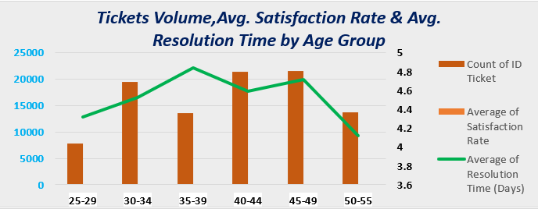

Insights-
- Overall, two age groups (40-44) & (45-49) handles more than 21,000 tickets as compared to others group & younger age group handles less than 10,000 tickets.
- Avg. employee satisfaction rate is least for Mid (35-39) Age Group, followed by (40-44) Age Group & (45-49) Age group.
- Highest satisfaction rate recorded over the years in Age Group (25-29) & (30-34) Age Group followed by Most Senior (50-55) Age Group.
- Over the years, the Mid Age Group (35-39) & Senior (45-49) Age Group takes highest resolution time for resolving the tickets & most senior level group (50-55) & younger Age Group (25-29) takes least time for fixing.
Recommendations-
- Special Focused on Mid Age Group (35-39) & Senior (45-49) Age Group by providing additional Skill training to improve the satisfaction rate and reduce the resolution time.
- Investment on upgrading ticket software & training programs for all the groups especially for younger Age Group (25-29), Mid Age Group (35-39) & most senior Age Group (50-55) for handling & prioritized more tickets in efficient way.
- Distribute the tickets in equal proportion to other age groups, so that high-volume groups (40–44 & 45–49) don’t get overloaded.

(Q9) Identify the trends for IT support operations based on ticket volumes and satisfaction, and mention the peak and stable times?
Analysis: Use pivot tables and charts to identify peak and off-peak hours.

Approach- A pivot table is created by organizing Months in Rows, Avg. Satisfaction Rate & Count of ID Tickets in Values, Also, a slicer is added to filter the data by year.
Refers To: SUBJECTIVE Q9 Sheet.

Month | Average of Satisfaction Rate | Count of ID Ticket
JAN | 4.151615576 | 7242
FEB | 4.071763068 | 7901
MAR | 4.073650948 | 8228
APR | 4.113770946 | 7937
MAY | 4.110700653 | 8121
JUN | 4.09249478 | 8141
JUL | 4.124039653 | 8070
AUG | 4.098598186 | 8489
SEP | 4.102323884 | 8219
OCT | 4.081341966 | 8495
NOV | 4.093409256 | 8254
DEC | 4.100702297 | 8401
Grand Total | 4.100648218 | 97498

Insights & Recommendations-
- From table & chart analysis, it indicates that over the years the top Peak months (handles above 8,400 tickets) are Aug, Nov & Dec & Peak-off months (handles less than 8,000 tickets) are Jan, Feb & Apr.

- While, highest month-wise avg. satisfaction is recorded in Jan followed by Jul & Apr & least avg. satisfaction recorded in Jun, despite good volume of tickets (8141).

- If we look for highest & lowest avg. satisfaction rate for each year then- Highest avg. satisfaction recorded in 2020 (4.16) & lowest avg. recorded in 2016 (3.97), it indicates the agents consistently improving the satisfaction rate year by year.

- No. of tickets handling increases from 13051 tickets (2016 year) to 29,088 tickets (2020 year), it indicates agent’s strong adaptability & reliability under growing pressure.

- During peak months, additional resources and agents are required to handle the increased ticket volume and maintain customer satisfaction.

- Planning and improvements should be made during off-peak months, such as upgrading the ticketing system, automating unassigned tickets, analyzing trends, and resolving backlog tickets that require specialized technical skills.

(Q10) What metrics should be included in the final dashboard to provide a comprehensive view of call centre performance and guide investment decisions?
Approach- There are some key Metrics/KPIs, which are included in final dashboard:
Refers To: SUBJECTIVE Q10 (Dashboard).
- Total No. of Tickets (Ticket Volume)
- No. of Agents
- Avg. Resolution Time (Days) to Fix the Issue.
- Avg. Satisfaction Rate.
- Ticket Volume Over Time (Year).
- Ticket Volume, Avg. Satisfaction Rate & Avg. Resolution Time by Age Group.
- Volume of Tickets by Severity (Priority-Based).
- Avg. Resolution Time (Days) by Request Category (Severity-Based).
- Peak & Off-Peak Months.
- Distribution of Tickets by Request Category.
- Slicers: Year, Priority & Severity.

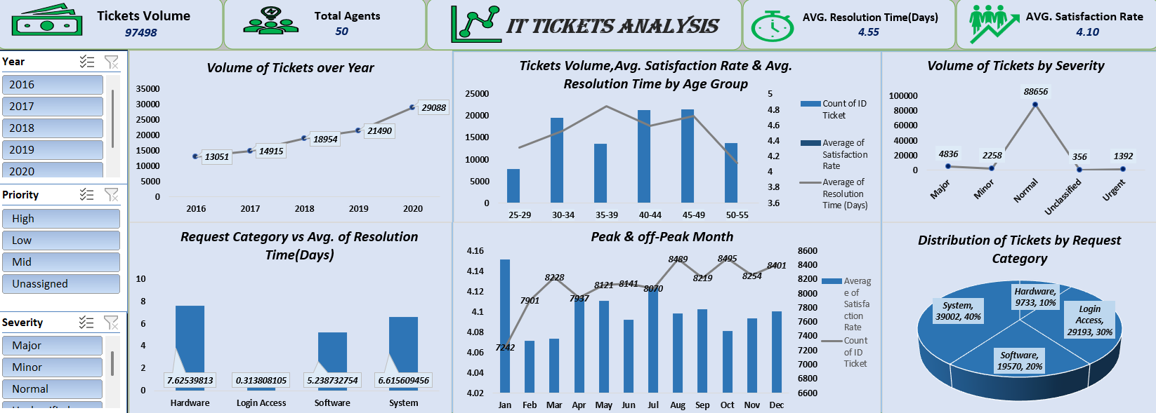
---------------------------------------------END-------------------------------------------

